Kafka-Based Data Sorting Application

Assignment Documentation

1. Overview
This project demonstrates a Kafka-based data processing application packaged and distributed using Docker.
The application consumes data, processes it, and publishes sorted results into multiple Kafka topics.
The entire setup is containerized to ensure reproducibility and ease of execution. The application completes execution within 3–5 minutes, after which the output can be verified using Kafka console consumers.

2. Docker Image Details
The application Docker image has been built and pushed to Docker Hub.
Docker Image Name:
saianirudh711/kafka-sort

3. Pulling the Docker Image
To retrieve the image from Docker Hub, run the following command:
docker pull saianirudh711/kafka-sort

4. Running the Application Container
The container must be run with sufficient memory and CPU resources to ensure smooth execution.
sudo docker run \
--name kafka-sort \
--rm \
-it \
--memory=2g \
--memory-swap=2g \
--cpus=4 \
saianirudh711/kafka-sort

Notes:
- The application runs and completes its Kafka processing tasks within 3–5 minutes.
- Kafka runs locally inside the container on port 9092.

5. Kafka Topics Created
The application produces data into the following Kafka topics:
- id
- name
- continent
Each topic contains processed records published by the application.

6. Verifying Kafka Output
After the container is running, open a new terminal and execute Kafka console consumer commands inside the container.

6.1 Access the Running Container
sudo docker exec -it kafka-sort bash

6.2 Consume Messages from id Topic
/opt/kafka/bin/kafka-console-consumer.sh \
--bootstrap-server localhost:9092 \
--topic id \
--from-beginning \
--max-messages 20

Ex out put :
83,HxsZHhkOeU,WTOYodjcSHPxkUf,Australia
106,hFgVwjTKoO,bfEajfUwQYPHcOL,Asia
202,RSaBYsjtFQ,bmVRzOPntLbpDRL,Asia
227,zxNDHvmHjr,KPxFhpNUHstuTpY,South America
242,YIjeXupFDD,sEmrhVLcaqalXfx,Europe
261,aTmJwXJIht,LLIwOnCPvUZIEHv,North America
293,pHdcePfxgA,vXXMKwfhXuPaUWc,Africa
303,lQYpuOQRGV,mRZApCdCpuEHHiD,Asia
305,jIwZHQkPIB,qCjRZxDFpNIESWp,Asia
332,iKrIxBsCcJ,TxglzwLrWAogOMd,Australia
353,fYdKFakNpH,xilljCBxnkKmLzm,South America
371,lSQpWECOXg,kgTnBhhIIVwvXYF,Asia
407,eukXGwpZnc,tFEhpkaiDljLGFi,South America
464,yrBMQGgkAb,xSIfwKSqIkHCFqk,Africa
512,MlhIleIgCe,rwFtJkzDWQoBzAw,Asia
621,GicLEAsLCs,cMYtiNGfSIWNRDR,North America
645,FiBBVPjlxY,qnZKjoneDXZSaBz,Africa
652,FeGwlOrMKY,VQWgqbhRhhNkSow,Europe
665,szATZFSsaP,RRjXyocMttRsUau,North America
772,RlyhLhuehf,PLuzdYoSxuUZjGO,North America
Processed a total of 20 messages

6.3 Consume Messages from name Topic
/opt/kafka/bin/kafka-console-consumer.sh \
--bootstrap-server localhost:9092 \
--topic name \
--from-beginning \
--max-messages 20

6.4 Consume Messages from continent Topic
/opt/kafka/bin/kafka-console-consumer.sh \
--bootstrap-server localhost:9092 \
--topic continent \
--from-beginning \
--max-messages 20

These commands allow verification of the first 20 messages published to each topic.

7. Checking Number of Messages in Each Topic
To determine how many messages exist in each Kafka topic, use the following command:
/opt/kafka/bin/kafka-get-offsets.sh \
--bootstrap-server localhost:9092 \
--topic topic-name

Example: Checking Message Count for continent Topic
/opt/kafka/bin/kafka-get-offsets.sh \
--bootstrap-server localhost:9092 \
--topic continent

Ex - output : continent:0:5000000

7. Technical Details

7.1. Batch-Based Data Upload to Source
The application ingests source data using batch uploads rather than individual record inserts.
Batching significantly reduces I/O overhead and improves throughput during data ingestion.

Key Characteristics:
- Source data is uploaded in fixed-size batches
- Each batch is processed independently
- Batch ingestion improves performance and minimizes network and disk I/O calls
- Ensures stable performance under large data volumes

7.2. Multi-Threaded Processing Model
The application uses a multi-threaded execution model to process incoming data efficiently.

Thread Responsibilities:
- Each processing thread handles a subset of the incoming data stream
- Threads operate independently to avoid contention
- Processing is parallelized to utilize available CPU cores efficiently

7.3. Sorting Logic ( heap + merge )
Within each processing thread, data is sorted using standard UNIX utilities.

Processing Flow:
- Incoming batch data is passed through heap to limit the working set size
- Data is sorted merging the collected files and ingested to the kafka topic
- Sorted results are forwarded for Kafka publication

7.4. Disk Persistence Every 5,000 Records
To prevent excessive memory usage and ensure fault tolerance, the application persists intermediate results to disk.

Persistence Strategy:
- Each thread writes processed data to disk after every 5,000 records
- Disk flush acts as a checkpoint mechanism
- Prevents memory exhaustion during large data processing
- Allows partial recovery in case of failure

7.5. High Level Design

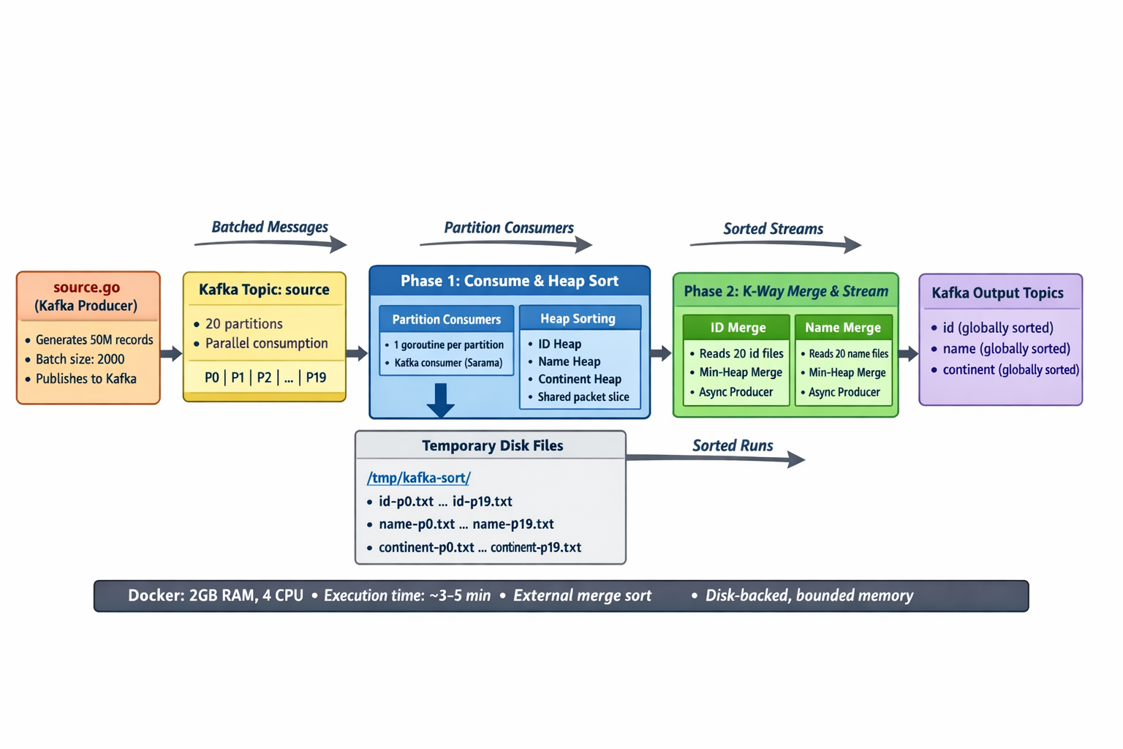

8. Execution Summary
- The application is fully containerized using Docker.
- Kafka runs internally within the container.
- Data is processed and published to three Kafka topics: id, name, and continent.
- Execution time is approximately 3–5 minutes.
- Output verification and message counts are performed using Kafka CLI tools.

